AWARDS

DISTINGUISHED BEST TEACHER STATE AWARDS
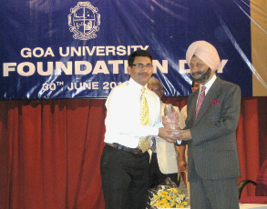
2010-2011:
PROF. NANDKUMAR SAWANT
BEST TEACHER SILVER JUBILEE AWARD BY GOA UNIVERSITY.
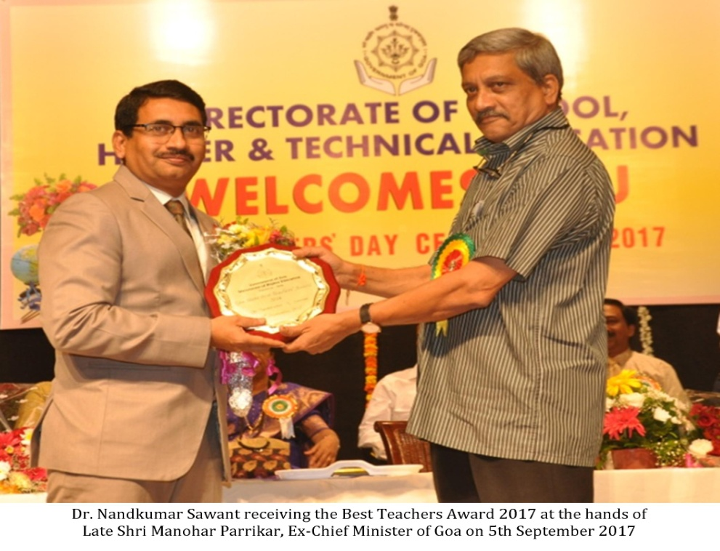
2017
PROF. NANDKUMAR SAWANT
BEST TEACHER STATE AWARD 2017
FOUNDER’S DAY – BEST TEACHER AWARD BY MANAGEMENT
The institution has instituted research awards since 2010. Every year, on Founders day, award for excellence in research and consultancy is given to the faculty who the highest Academic Performance Index scores (API) in Research and consultancy of three consecutive years. The recipients of these awards are listed below:

 | Awardee | Founders Day Best Teacher Awards Received
1 | 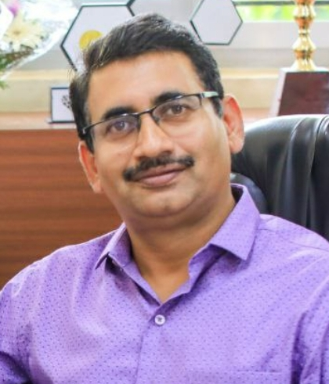  PROF. NANDKUMAR SAWANT  Professor & Head- Department of Geography and Research Centre | - 2010 -2011: Best Teacher Award -Excellence in Research and Consultancy  - 2014-2015: Best Teacher Award -Excellence in Research and Consultancy
2 | DR. NANDINI VAZ FERNANDES  Associate Professor & Head- Department of Zoology | - 2011-2012: Best Teacher Award-Excellence in Research and Consultancy.  - 2014-2015: Best Teacher Award -Excellence in Student related activities.  - 2016-2017: Cornerstone Award- Best Teacher Award Excellence in Research and Consultancy  - 2018-2019: Cornerstone Award: Best Teacher Award -Excellence in Student related activities.
3 | 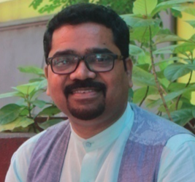  DR. HANUMANT CHOPDEKAR  Head  Former Department of Konkani  (Joined at Goa University- 2020) | 2018-2019: Cornerstone Award - Excellence in Research
4 | 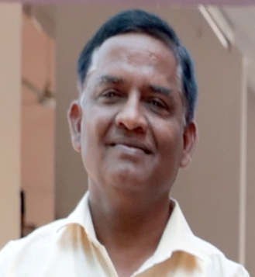SHRI. SHRIKRISHNA ADSUL  Associate Professor and Head  Department of Marathi  (Retd. In 2019) | 2012-2013: Best Teacher Award-Excellence in Research and Consultancy.
4 | 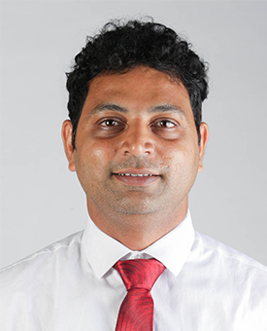  DR. SACHIN MORAES  Assistant Professor & Head  Department of Sociology | 2015-2016: Best Teacher Award-Excellence in Student Related activities
5 | 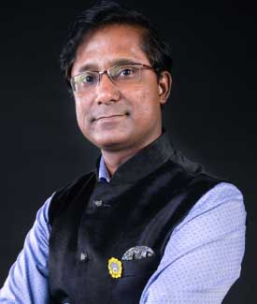  SHRI. ANDREW BARETTO  Asst.Professor  Department of English | 2016-2017: Cornerstone Award - Excellence in Student Related activities and public relations.
6 | 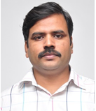  DR. SANJAY GAIKWAD  Assistant Professor  Department of Geography | 2015-2016: Best Teacher Award-Excellence in Research and Consultancy
7 | 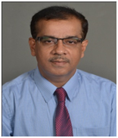  DR. ANIMESH ADHIKARI  Associate Professor  Department of Computer Science  (Retd: 2018) | 2009-2010: Best Teacher Award-Excellence in Research and Consultancy

AWARDEES
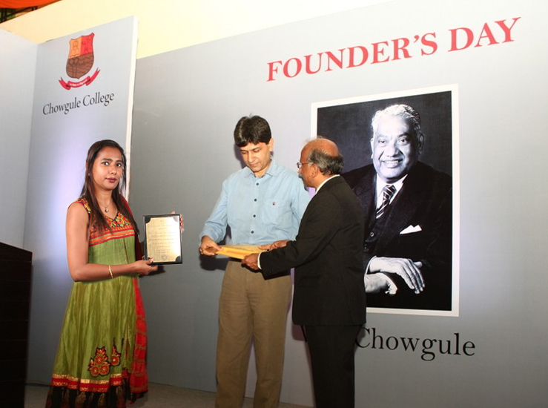
2011-2012
DR. NANDINI VAZ FERNANDES
Best Teacher Award-Excellence in Research and Consultancy

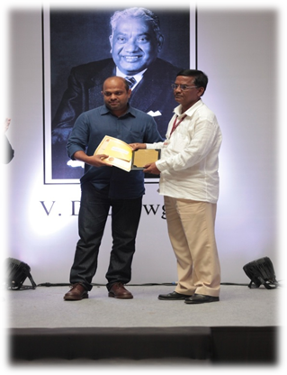
2012-2013
PROF. SHRI KRISHNA ADSUL
Best Teacher Award-Excellence in Research and Consultancy

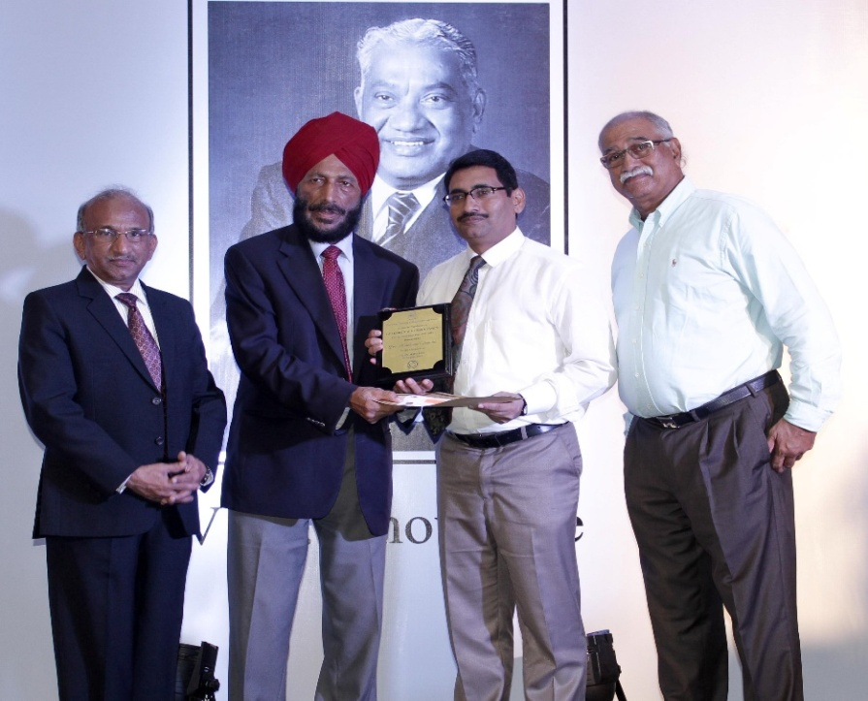

2014-2015
DR. NANDKUMAR SAWANT
Best Teacher Award -Excellence in Research and Consultancy

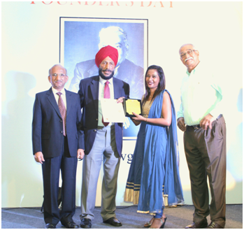
2014-2015
DR. NANDINI VAZ FERNANDES
Best Teacher Award -Excellence in Student related activities.

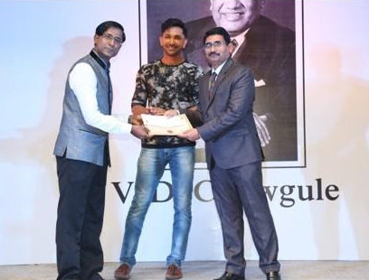
2016-2017
SHRI. ANDREW BARETTO
Cornerstone Award - Excellence in Student Related activities and public relations.

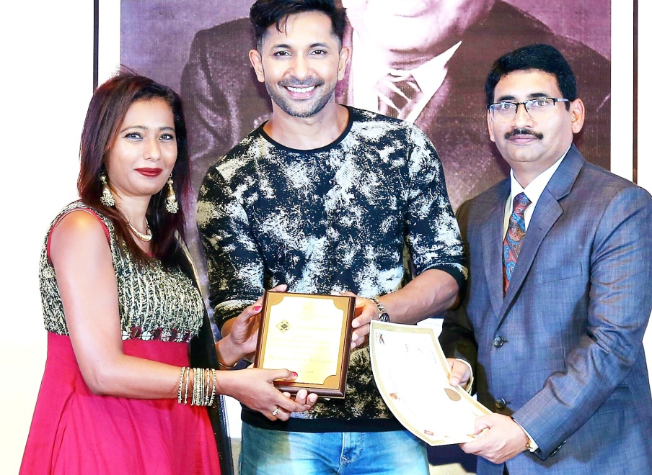

2016-2017
DR. NANDINI VAZ FERNANDES:
Cornerstone Award - Excellence in Research and Consultancy

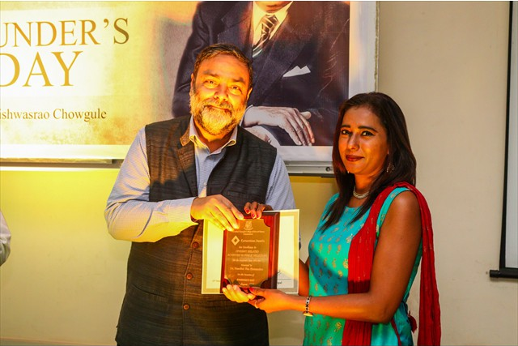

2018-2019
DR. NANDINI VAZ FERNANDES:
Cornerstone Award - Excellence in Student Related activities and public relations

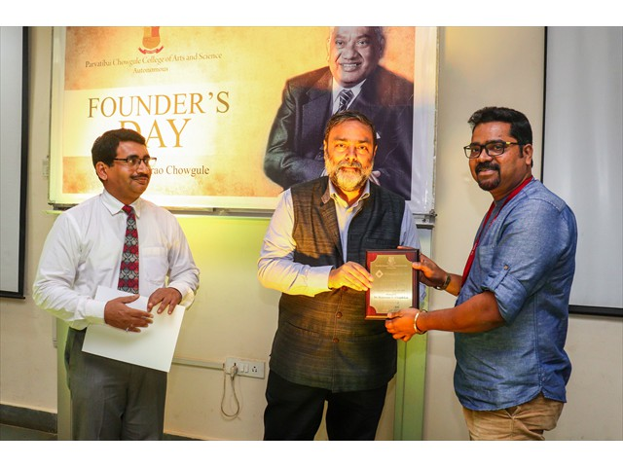
2018-2019
DR. HANUMANT CHOPDEKAR
Cornerstone Award - Excellence in Research and Consultancy

***

